**The Circulatory System**

**The Role of the Circulatory System**

* List the components of the circulatory system.  
  The components of the circulatory system are the heart, veins, arteries, venules, arterioles, capillaries, and blood.
* Outline the role of the circulatory system.  
  The circulatory system transports glucose, oxygen, amino acids, fatty acids, vitamins, and minerals to every cell in the body via blood. It removes waste from each cell, for excretion in the kidneys or lungs. It interconnects all other systems of the body (e.g. digestive, respiratory, and excretory systems).

**The Mammalian Heart**

* Use the diagram to write a statement detailing the journey that blood takes through the circulatory system of a mammal.  
  Oxygenated blood exits through the aorta and is transported to cells all over the body, where it delivers cells oxygen through the capillaries. The deoxygenated blood is then carried out by the capillaries and travels through veins back to the heart, where it enters the right atrium, then moves into the right ventricle. Deoxygenated blood in the right ventricle is pushed into the pulmonary arteries, making its way to the capillaries within the lungs, where it is oxygenated. This newly oxygenated blood enters the heart’s left atrium through the pulmonary veins, then to the left ventricle and out of the heart via the aorta.

**Chambers of the Heart**

* Compare the circulatory systems of fish, amphibians and mammals  
  Fish have simpler circulatory systems with a two-chambered heart (1 atrium and 1 ventricle), whereas amphibians + most reptiles have three-chambered hearts with 2 atria and 1 ventricle (oxygenated and deoxygenated blood mixes, system in “figure-8”; blood travels from lungs and back to heart before going to the rest of the body). Birds, mammals, and crocodiles have 4-chambered hearts, with 2 atria and 2 ventricles, the oxygenated and deoxygenated blood do not mix (unlike amphibians and reptiles), and they share the same “figure-8”.

**Arteries and Veins**

* Compare the structure and function of arteries and veins.  
  Arteries carry oxygenated blood away from the heart to the tissues in the body (apart from the pulmonary arteries, which carry blood to the lungs for oxygenation), while veins carry deoxygenated blood from the tissues toward the heart (excluding the pulmonary and umbilical veins that carry oxygenated blood to the heart). The walls of arteries are thick and muscular to withstand much higher blood pressure, and conversely, vein walls are thinner and less muscular due to handling lower pressure blood and being closer to the skin than arteries. Veins tend to have valves to prevent backflow, whereas arteries do not require valves because of the higher pressure.

**Arterioles and Venules**

* Outline the role of arterioles and venules  
  Arterioles and venules act as immediate connections between arteries and veins to the capillaries. Arterioles are smaller vessels that branch out from the arteries, and venules are smaller vessels that connect from the capillaries to the veins.

**Capillaries**

* Draw a diagram showing the diffusion of molecules from capillaries into the surrounding cells  
  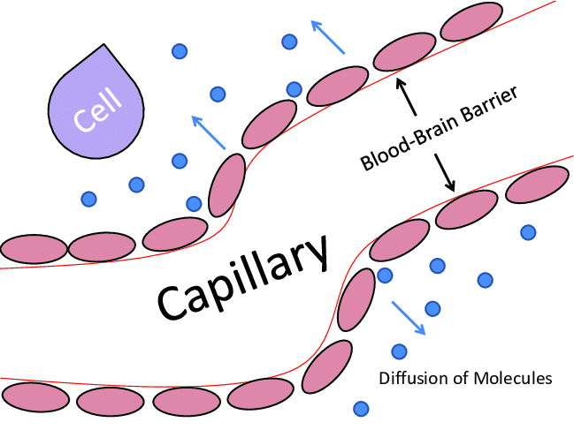

**Check for Understanding**

* Complete questions (11 in total!) for both data sets